FOUNDATION FOR VIRTUAL AND AUGMENTED REALITY SYSTEMS
Lecture07
Lec 7: Historial Evolution
Hello and welcome to the Foundation for Virtual and Augmented Reality Systems, this NPTEL MOOCs course. We are going to continue our discussion on the evolution of the field, the history in this part of lecture 4. So, earlier we talked about the historical evolution of the virtual reality field. Now, we are going to talk about the other area, that is augmented reality, how it evolved over time.
Like in virtual reality, here also we can divide the overall evolution into distinct phases. However, unlike in virtual reality, the phases here may sometimes overlap. Although I use the term distinct, sometimes the distinctions may be very less. So, it is possible to overlap. Now, broadly, we can divide it into four phases.
As shown here, experimental phase, which happened before the 1980s of the last century. So, whatever happened there at that time, primarily related to early experimentation, which defined the concepts and showed different types of technology required that we are calling experimental phase. Then we have the basic research phase between the 1980s to mid-1990s. During this phase, research into enabling technologies such as tracking, displays, and input devices happened.
Then we can have one phase called the tools or applications phase from the mid-1990s to 2007. During this phase, early applications and different exploratory tasks related to interaction techniques as well as usability of such apps and design theory related to AR were developed. worked on or explored. Finally, we have the commercial application phase starting from 2007, which is continuing to date. Now, during this phase what happened is that widespread AR availability was there and still we can see newer and newer applications are coming into the market.
in different domains of applications such as gaming, medicine, mobile, commerce, marketing, and so on. So, broadly four phases. Now, let us have a quick look at major developments which define these phases. So, we will start with the first one, that is the experimentation phase. Now, the first
truly computer-generated AR experience can be traced back to the work of Ivan Sutherland. You may recollect that during the discussion on the history of VR, we also referred to him, his Sword of Damocles invention as one of the earliest examples of headsets. Now the same person can be attributed to the first truly computer-generated AR experience. That happened in 1968.
So, he along with Bob Sproull together created the first prototype AR system. Now, in the system, what did they do? They combined a CRT-based, that is cathode ray tube-based, optical see-through head mounted display or HMD. with a ceiling-mounted mechanical tracking system connected to a PDP-11 computer and custom graphics hardware. Similar to the system that we have seen during the discussion on VR history.
Now, this tracking system was used to track the head movements and accordingly register things in 3D, one of the key characteristics of AR. Augmented reality as we have discussed in the previous lecture. Now, this mechanical tracker was later replaced by an ultrasonic system. So, this early system looked something like this. Note that it is an AR headset with optical see-through devices or display as seen here.
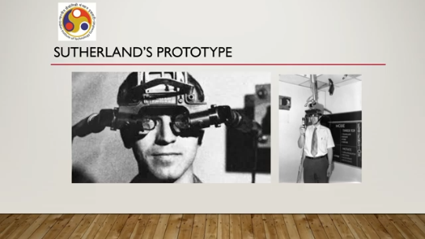
The headset is worn, then it is connected to a ceiling-mounted mechanical tracker so that any movement can be detected and accordingly things can be displayed on the see-through display by proper 3D registering. So, this was the earliest example of a truly computer-generated augmented reality system using an augmented reality headset. Around the same time, Tom Furness at the Wright-Patterson Air Force Base was beginning his research on the super cockpit program of the US Air Force. That is another major program that resulted in many relevant technologies that are part of augmented reality.
So, in the prototype system that was made. Users wore an HMD while sitting in the aircraft cockpit. Now, during daylight, the computer graphics appeared superimposed over the part of the pilot's real world view. That is typically what we can expect in an AR headset.
So, augmentation of real world view with computer-generated imagery. During nighttime and in bad weather conditions when visibility was poor, the display could show graphics that appeared as a substitute for the real world, replacing the user's view. So, when things are clearly visible, then the pilot could see the real world, with augmentation of the view with digital content, whereas when things were not clearly visible, the pilot could see virtual things, that is, computer-generated imagery. That was the overall thing that was there as part of the prototype.
These early experiments, or all these experiments that happened, evolved into head-mounted AR displays that we use in modern aircraft. So, already, this type of display is quite commonly used in modern aircraft, and those early experiments resulted in the development of such displays. In fact, not only AR displays, those works actually led to major developments in VR displays as well. Not only that, they also led to work on the input and tracking technologies on the hardware side. For example, the VIVED display that we talked about earlier,
during the discussion on VR history, was developed during that period while these experiments were going on, which was one of the earliest examples of VR displays, HMDs. Now, once this experimentation phase is over, we enter the basic research phase. Much influential work done in the 1990s shaped the field, which is part of this phase. Tom Caudell published the first academic article with the term augmented reality during this phase in the year 1992.
Now, He is often credited with coining the phrase augmented reality because of the appearance of this term in his paper, in his article in 1992. Then at the University of North Carolina, several research projects were carried out during this phase which helped in the development of the field. One was related to registration tracking techniques. carried out during 93, 94.
Then early research on see-through head mounted displays typically used in AR during the period 95, 96, and several applications were also developed along with the basic research. At Columbia University during the same period, One of the first academic papers on AR describing the KARMA system was published in 1993. Then work was done related to AR interaction methods, how to interact with the augmented digital content. And also, interestingly, work was carried out on mobile AR systems.
Some publications were there in 1997, whereas these interaction methods, the works that were carried out under this topic, were done in 1993. At the University of Toronto in Canada, other research activities were going on during this period. Notable among them was research on overlaying virtual cues on stereoscopic video. During the period from 1991 to 1993, these works were carried out. Then work was also carried out on AR applications between 1992 and 1993 during this period.
Now, while these research works were going on, parallel activities were happening on the handheld and mobile AR front. One early example is the Chameleon system. Developed in 1993, it allowed a person to move an LCD display over a piece of paper and see virtual content. Similar applications nowadays are quite popular, but at that time it was quite novel. Then NaviCam by Rekimoto in 1995.
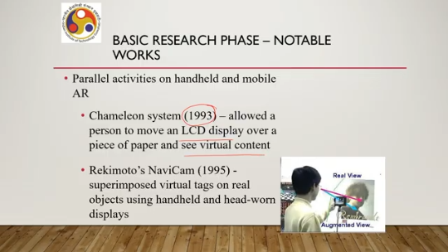
It superimposed virtual tags on real objects using handheld and head-mounted displays. as shown in this accompanying figure. So, these are true AR-type applications as we understand AR and the kind of applications that we see nowadays; these are the precursors to this type of application. Now, by the mid-1990s. different things started happening.
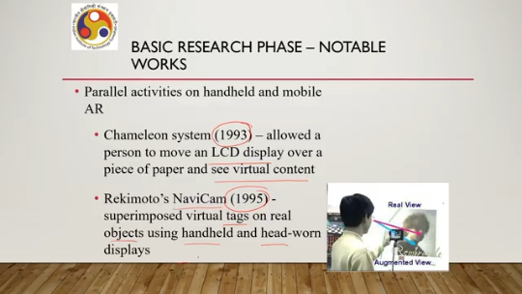
So, we can roughly call it to be a different phase that is the tools or applications phase. Now, notable works in this period include research on some key enabling technologies for AR, such as tracking, display, and interaction. Now, what kind of work was carried out during that period? Work on systems that allowed people in the same location to see and interact with shared AR content. Different than what was happening earlier.
Then medical applications, such as visualization of laparoscopic surgery, X-ray visualization in the patient's body, and for image-guided surgery. These were also being worked on. Starting from the 1990s, the middle of the 1990s. One related research area that was emerging at the time was wearable computing using HMDs. Of course, it was there earlier also, but people started paying more attention to these types of devices.
Then there was work on AR overlay on real-world markers using computer vision techniques, which happened in the later part of the 1990s, specifically in 1997. Wearable computers with GPS tracking to produce a number of outdoor AR interfaces for showing information in place in the real world. In other words, The tracking was used to register the content in 3D. We have already introduced these terms.
So let us use these terms to better understand the applications. So the tracking technology was done to register the content in 3D. That again happened in 1997. Then terrestrial navigation applications, of outdoor wearable AR interfaces for viewing and creating CAD models on site and also applications related to game playing.
These started happening in the first half of the new century, first decade of the new century, specifically 2002 and 2003. However, it may be noted that the systems that were being developed at that time or being worked with at that time were bulky due to the size of, the custom computer hardware, batteries, tracking sensors, and display hardware. You can see some examples here in the accompanying figure. So, this is the entire setup owned.
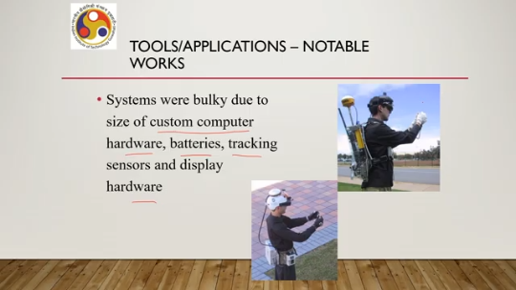
So, this is technically wearable computers. But as you can see there is a headset with the computer being carried in the backpack and then interaction means of interaction through different input devices. But as the figures as the images reveal these were quite bulky difficult to use. Another activity that took place at that time was to address one of the most significant challenges of AR, that is viewpoint tracking. How do you track the viewpoint?
So that this registration in 3D happens accurately. In 1996, Rekimoto developed a simple computer vision tracking system based on printed matrix that evolved into a cyber code system, into the cyber code system. Then Kato and Billinghurst in 1999 developed the AR Toolkit tracking library, which was released in 2000 as open-source software. It also provided real-time computer vision based tracking of a square marker.
So, these are related to development of software which could enable the system to track user's viewpoint. In 2004, the first mobile phone based AR application was demonstrated. as you can see here in the accompanying figure. Now, this was followed by porting of AR Toolkit to mobile phones in 2004 itself. But as you can see in the accompanying figure, mobile phones were of different looks at that time as compared to modern-day smartphones,
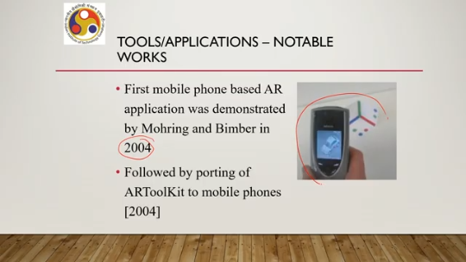
but still people tried to use those phones to develop mobile-based AR applications. So these are some of the notable developments related to this phase of tools and applications. So as you can see several tools were developed during this phase related to tracking, related to mobile applications and related to applications on wearable devices. Finally, we come to the commercial application phase. This phase is still the one going on.
Now We can roughly say that this phase started in 2007, more specifically in October 2007, when Sony PlayStation 3 based game, The Eye of Judgment, was released. Now, this is one of the first widely used consumer AR experiences. Until that time, AR was still not very popular. Popular or not easily available.
With the launch of this game, we can say that we entered the commercial phase where such kinds of AR experiences started becoming very popular. Then 2009 represented another turning point for AR. It moved from research laboratories and specialist applications to widely available commercial technology, starting in 2009. And this happened mainly due to three factors. The emergence of Adobe Flash-based AR authoring tools, which made, starting from 2008,
which made experiencing AR through web browsers possible, thus making it available to a larger mass. Then, smartphone-based AR. So, we had entered the era of smartphones by that time. And finally, the use of AR for global marketing campaigns. So, commercial interest also grew, and marketers started seeing the huge potential in such types of AR applications.
Increasing sales and making products popular. Then in 2017, Apple launched this ARKit SDK for AR system development. Google released ARCore for Android OS or Android platforms. Now, these again further stimulated the growth in the field by enabling a large number of developers to devote time to developing AR applications. So, the number of applications increased heavily and more and more people started using such applications, starting from very simple applications to quite complex applications.
As we have seen in our earlier lecture on AR applications. But the real spark came during this period starting from 2017 onwards with the launch of ARKit and ARCore. And as we have seen in the case of VR, virtual reality, the story continues here as well. So, we are still in the commercial growth phase. Where it is expected that as time passes, more and more such applications and tools will become available.
More improvements are going to take place in hardware, particularly in terms of wearable devices, mobile devices, and holographic projection-based devices. Also, with the advent of algorithms, the advent of AI, and the advent of computer vision technologies, tracking and registration in 3D will become more and more feasible on available low-end devices as well. So, from here we can only expect growth, further growth, and the story continues. So, with that, we have come to the end of this lecture.
So, what have we covered so far? We covered historical milestones for both AR and VR. VR milestones we discussed in the previous part of the lecture. We saw that there were four phases, distinct phases of evolution in VR. Similarly, we tried to categorize the evolution into four phases for AR.
And we have seen what the notable developments were during each of these phases. Now, that is in brief the historical evolution of the field. And I hope you have enjoyed this brief exposure to history. There are many more things that happened. We only covered some key developments.
Next, in the next lecture, what we are going to do is take up the issues and challenges and discuss those related to these technologies. So, for AR-related history, you can refer to this paper, this article by Billinghurst et al., It was published in 2015. So, go through it to know more in detail about the historical evolution. So, with that, I would like to end this lecture.

I hope you have enjoyed the discussion. Looking forward to seeing you all in the next lecture. Till then, thank you, goodbye and happy learning.

